**Venus Summer Greenhouse Pilot Study**

**Goal** - To see if soil function and plant fitness is affected by resuscitated members of the microbial seed bank via Rpf application. Additionally, I want to see how training soil with a plant root system will result in an increase microbial activity.

**Rationale**

Before I can do any large scale, multiple species, and feedback greenhouse experiment - I must know that plants and microbial community experience a physiological/functional change in the soil matrix with Rpf addition resulting from microbial seed banks waking up.

**Background**

Belowground microbial community strongly influence plant community structure (Reynolds *et al*. 2013), and plant productivity (Hooper *et al*. 2005; van der Heijden *et al*. 2008), likely as a result of mediating plant evolutionary processes (Lau and Lennon 2012). Plants often depend on microbial associations for survival (Rodriguez and Redman 2008), and any changes in microbial structure can shift plant community structure and coexistence by altering feedback interactions between plants and microbes (Bever 1993; Reynolds *et al*. 2013). Indeed, existing symbiotic continuum frameworks has described plant-microbial interactions to range from mutualistic (positive) to parasitic (negative) for the plants (Carroll 1988; Bever 1997; Johnson *et al*. 1997). Furthermore, plant fitness can be improved when grown in soil harboring a diverse relative to simple microbial communities encompassing both bacteria and fungi (Lau and Lennon 2011).

Within plant-microbe interactions, only active microbes can participate but this excludes an entire potential pool of players present in the microbial seed bank from ecosystem and feedback models. A wide range of microorganisms engage in dormancy as a bet-hedging strategy that allows them to persist through periods of suboptimal environmental conditions. Dormancy contribute to the formation of diverse seed banks that increases coexistence among functionally redundant taxa (Warner and Chesson 1985) and increases the stability of ecosystem processes (McGrady-Steed *et al*. 1997; Naeem & Li 1997; Loreau *et al*. 2001; Hooper *et al*. 2005). Microbial dormancy is also implicated to be a driver of genetic biodiversity (Lennon and Jones 2010) and potential functional diversity that could impact ecosystem processes such as plant-soil feedbacks (Hooper *et al*. 2005).

**Hypothesis**

If members of the microbial seed bank contribute to the maintenance of genetic diversity, and likely functional diversity, then resuscitating the seed bank would result in (1) an altered interaction between plants and microbe that could be either negative or positive based on plant fitness changes; and (2) shift in community composition that may increase functionality of microbial communities based CO2 respiration fluxes. Furthermore, (3) proportions of active microbes may be elevated in soil trained by plant root systems because of the presence of root exudates in the soil matrix within the rhizosphere.

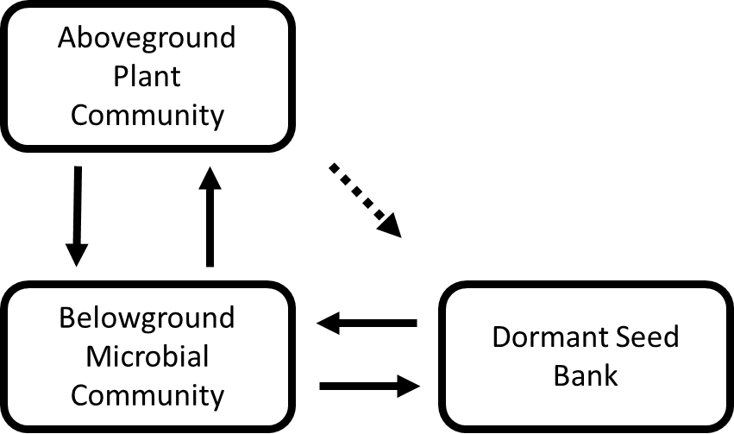

**Figure 1.** Aboveground plant communities structure belowground microbial communities by producing root exudates and belowground community may either parasitize or benefit plants. Soil microorganisms are constantly cycling between an active and dormant state. Aboveground plants may indirectly influence dormant seed bank structure with root exudates.

**Study Species**

Wisconsin Fast Grow Brassica Rapa mono-colonial seeds – using this because this is a fast growing species that is colonially the same to reduce variation among plants.

**Live Soil**

From Indiana University Research and Teaching Preserves in Griffy Woods.

**Experimental Set Up**

To investigate how both concentration and frequency of Rpf addition will alter plant fitness and soil microbial function, I will conduct a 3 × 2 factorial design mesocosms experiments in growth chambers using seeds of *Brassica rapa*. We will use sterilized plastic pots (~50cm diameter by ~30cm diameter height) filled with 3x autoclaved soil medium (1 part Metro mix; 1 part vermiculite) that will be inoculated at 1 part with live soil. There will be 3 Rpf treatments (high, low, and water control) and seeds would be sowed as according to diagram below.

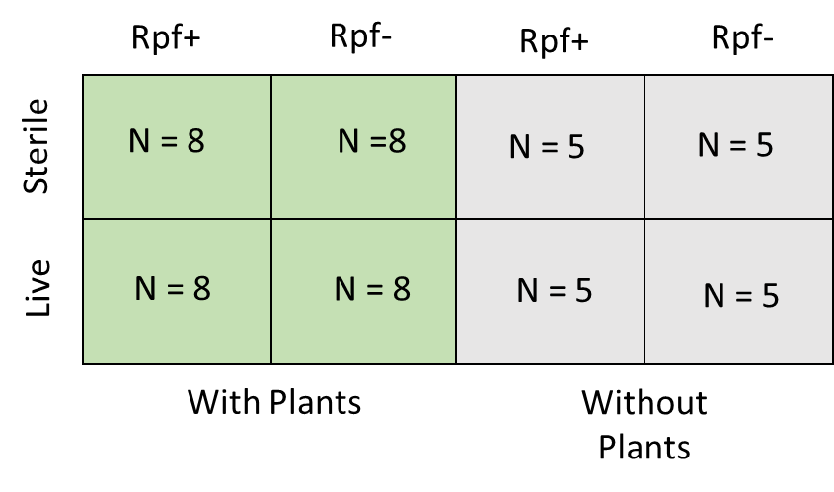

**Measurement**

I will measure the following

* CO2 respiration (which is indicative of microbial activity such as decomposition) – Every week immediately following Rpf+/Rpf- treatment addition
* Plant biomass/flower number/seed production/SLA (observable indication of plant fitness and effect of plant-soil interaction) – According to timeline in protocol
* Colony Forming Units (Microbial community characterization) – Every week

**Protocol**

1. Collect live soil from spots Griffy woods and homogenize
2. 3x autoclave soil medium (1 part Metro mix; 1 part vermiculite) and half of live soil for 45 minutes within a span of 72 hours.
3. Sterilize pots and trays and growth chamber with phizan and ethanol
4. Pots receiving live soil should be inoculated (1 part live soil)
5. Apply treatments of Rpf by applying in 3 spots around the plant once every week
   1. Rpf + : 150ul Rpf + 850uL H2O x 26 = 3.9mL Rpf + 22.1mL H2O
   2. Rpf - : 150ul Rpf Buffer + 850uL H2O x 26 = 3.9mL Rpf Buffer + 24.375mL

H2O

1. Collect 0 week soil sample
   1. **Destructive CO2 sampling –** Collect three 1 gram soil samples from each of the pots, label accordingly, and take measurement of 24 and 48 hour vials. The destructively sampled soils should be used next for plate dilutions in the following step. And the 48 hour destructively samples soils should be stored in environmental sample freezer. After use, vials should be cleaned up for reuse.
   2. **Pyro-phosphate solution dilution and plating** – Soil will be homogenized in falcon tube on the vortex for 30 minutes in pyro-phosphate solution. Dilutions will be done from soil solution in pyrophosphate solution to 10-6 dilution. 100uL of final dilution will be spread on R2A plates infused with 50uL/mL final concentration of cyclohexamide. Plates will be incubated for 4 days and then colonies will be counted on plate reader. **Done once a week same day**
   3. The **remaining soil will be stored in -80C freezer**
2. **Planting (Day 1):** Sow 2-3 seeds of *Brassica rapa* into each appropriate pot
3. Ensure that there is always water in the pot trays and that plants are watered once every day using e-pure water (prevent splashing)
4. Check every day for germination and mark germination time for each treatment
5. **Thinning plant (Day 4-5):** Ensure there is only one seedling in each pot, transplant if needed (use tweezers and prevent transferring soil in between pots)
6. **Count flowers and pollinate (Day 13-16)**: Count flowers and pollinate with flowers of another plant using paint brush on other open flowers, and sterilize in between with 30% isopropyl alcohol
7. **Measure SLA (Day 18)**: Measure the length and width in cm of the leaves of each plant
8. **Count seeds (Day 40):** 20 days after pollination, destructively harvest plants and allow to dry for 2 days under 65C heat lamps. Count seeds by gently rolling dry seedpods between hands or fingers over a paper towel and store in envelopes (Keep each seed batch separate from other reps or treatment).
9. **Weigh biomass:** After harvesting seeds, weigh overall plant mass, aboveground, and belowground.

**Expected Results**

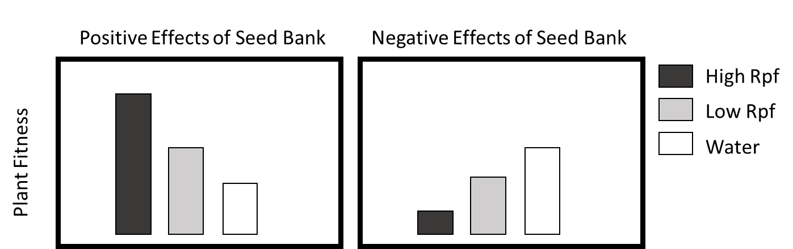

Figure 2.

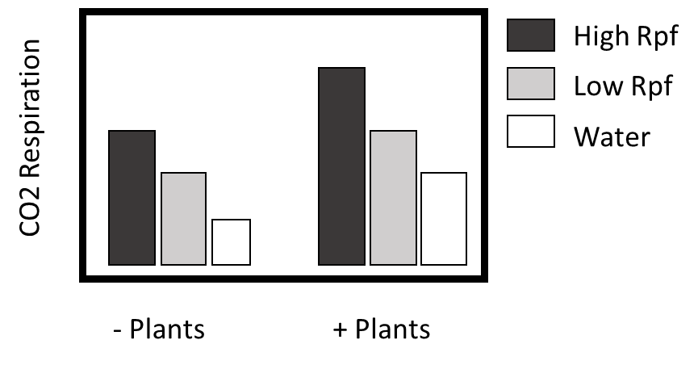

Figure 3.

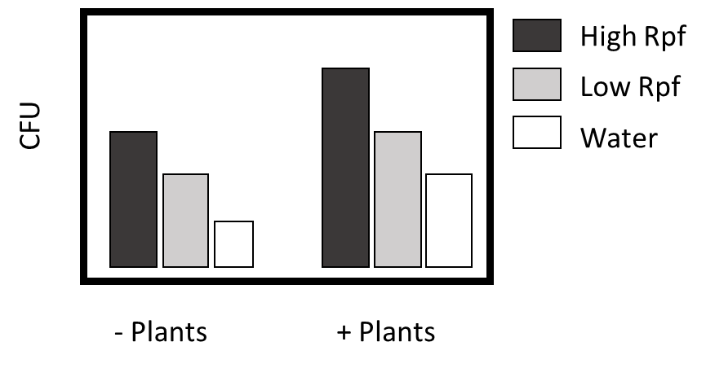

Figure 4.

**Reference**:

Bever, James D. "Negative feedback within a mutualism: host–specific growth of mycorrhizal fungi reduces plant benefit." *Proceedings of the Royal Society of London B: Biological Sciences* 269.1509 (2002): 2595-2601.

Carroll, George. "Fungal endophytes in stems and leaves: from latent pathogen to mutualistic symbiont." *Ecology* (1988): 2-9.

Hooper, David U., et al. "Effects of biodiversity on ecosystem functioning: a consensus of current knowledge." *Ecological monographs* 75.1 (2005): 3-35.

Johnson, N. C., J‐H. Graham, and F. A. Smith. "Functioning of mycorrhizal associations along the mutualism–parasitism continuum." *New phytologist*135.4 (1997): 575-585.

Lau, Jennifer A., and Jay T. Lennon. "Evolutionary ecology of plant–microbe interactions: soil microbial structure alters selection on plant traits." *New Phytologist* 192.1 (2011): 215-224.

Lau, Jennifer A., and Jay T. Lennon. "Rapid responses of soil microorganisms improve plant fitness in novel environments." *Proceedings of the National Academy of Sciences* 109.35 (2012): 14058-14062.

Loreau, Michel, et al. "Biodiversity and ecosystem functioning: current knowledge and future challenges." *science* 294.5543 (2001): 804-808.

McGrady-Steed, Jill, Patricia M. Harris, and Peter J. Morin. "Biodiversity regulates ecosystem predictability." *Nature* 390.6656 (1997): 162-165.

Naeem, Shahid, and Shibin Li. "Biodiversity enhances ecosystem reliability."*Nature* 390.6659 (1997): 507-509.

Reynolds, Heather L., et al. "Grassroots ecology: plant-microbe-soil interactions as drivers of plant community structure and dynamics." *Ecology*84.9 (2003): 2281-2291.

Rodriguez, Rusty, and Regina Redman. "More than 400 million years of evolution and some plants still can't make it on their own: plant stress tolerance via fungal symbiosis." *Journal of Experimental Botany* 59.5 (2008): 1109-1114.

Warner, Robert R., and Peter L. Chesson. "Coexistence mediated by recruitment fluctuations: a field guide to the storage effect." *American Naturalist* (1985): 769-787.

Van Der Heijden, Marcel GA, Richard D. Bardgett, and Nico M. Van Straalen. "The unseen majority: soil microbes as drivers of plant diversity and productivity in terrestrial ecosystems." *Ecology letters* 11.3 (2008): 296-310.